The artificial neutrophil and a proposal of an in silico research of the immune response in human bacterial diseases
O neutrófilo artificial e a proposta de investigação in silico da resposta imune nas doenças bacterianas humanas
Rodrigo Siqueira-Batista¹, Flávio Oliveira de Sousa², Andréia Patrícia Gomes¹, Alcione de Paiva Oliveira³, Izabella Soares de Oliveira⁴, Willian Farago², Carlos Antônio Bastos⁵, Maurílio de Araújo Possi⁵, Luiz Alberto Santana¹, Fábio Ribeiro Cerqueira³

RESUMO
Bacterial diseases are important conditions in human medicine. First, because of the epidemiological impact, and, second, due to the gravity of some of these infectious processes. It is worth to highlight bacterial sepsis and acute bacterial meningoencephalitis which are morbid conditions that can lead to death in a short period of time. In this context, neutrophils are extremely important cells in the interaction man / bacteria although many aspects of the performance of these cells remain awaiting elucidation. This paper presents the requirements for computational simulation of neutrophils in the AutoSimmune system and some preliminary description of the activity of this kind of cell in post-streptococcal glomerulonephritis, a major human disease that affects the kidneys. The preliminary results presented here is the support for further development of in silico studies on the role of neutrophils in bacterial diseases.
KEYWORDS: bacteria, immune system, informatics, medical informatics, neutrophils, multi-agent systems.

1 INTRODUCTION
Bacterial diseases have great clinical importance and significant magnitude in the context of infectious diseases, lying among the main causes of illness and death in the contemporary world (BUCHALLA et al., 2003; LUNA, 2002). As a result, the investigation of morbid conditions caused by bacteria has to incorporate research strategies aimed at (i) pathophysiological understanding (BAXT et al., 2013) – with emphasis on inflammatory events as well as the innate and adaptive immune response – (ii) diagnosis, (iii) treatment and (iv) prevention and control. At the same time, bioethical issues have to be taken into account for studies involving living beings, mainly humans. Risks and needs must be clearly identified for conducting research that follows best suited bioethical standards.
From this perspective of ethical aspects, the use of in silico experimentation to study the immune response to infectious agents (Bastos, 2013; POSSI, 2012) may broaden the understanding of the intricate mechanisms of pathogenic interaction (in this case, bacteria / Homo sapiens sapiens). This may contribute for expanding the set of hypotheses investigated (that, otherwise, would be tested only in vitro and/or in vivo), with less time and cost, in addition to avoiding ethical issues. In silico studies, therefore, might be an important research approach in conjunction with biological and clinical methods (SIQUEIRA-BATISTA et al., 2012a).
The scope of this article is to present a delineation to simulate the neutrophil behavior – which is an essential cell in bacterial infections response (CRISS & HS SEIFERT, 2012; RIGBY & DELEO, 2012) – in a computer simulator of the immune system (IS) called AutoSimmune (POSSI, 2012), which was designed and implemented using a multi-agent approach.

2 NEUTROPHILS AND IMMUNE RESPONSE TO BACTERIAL INFECTIONS
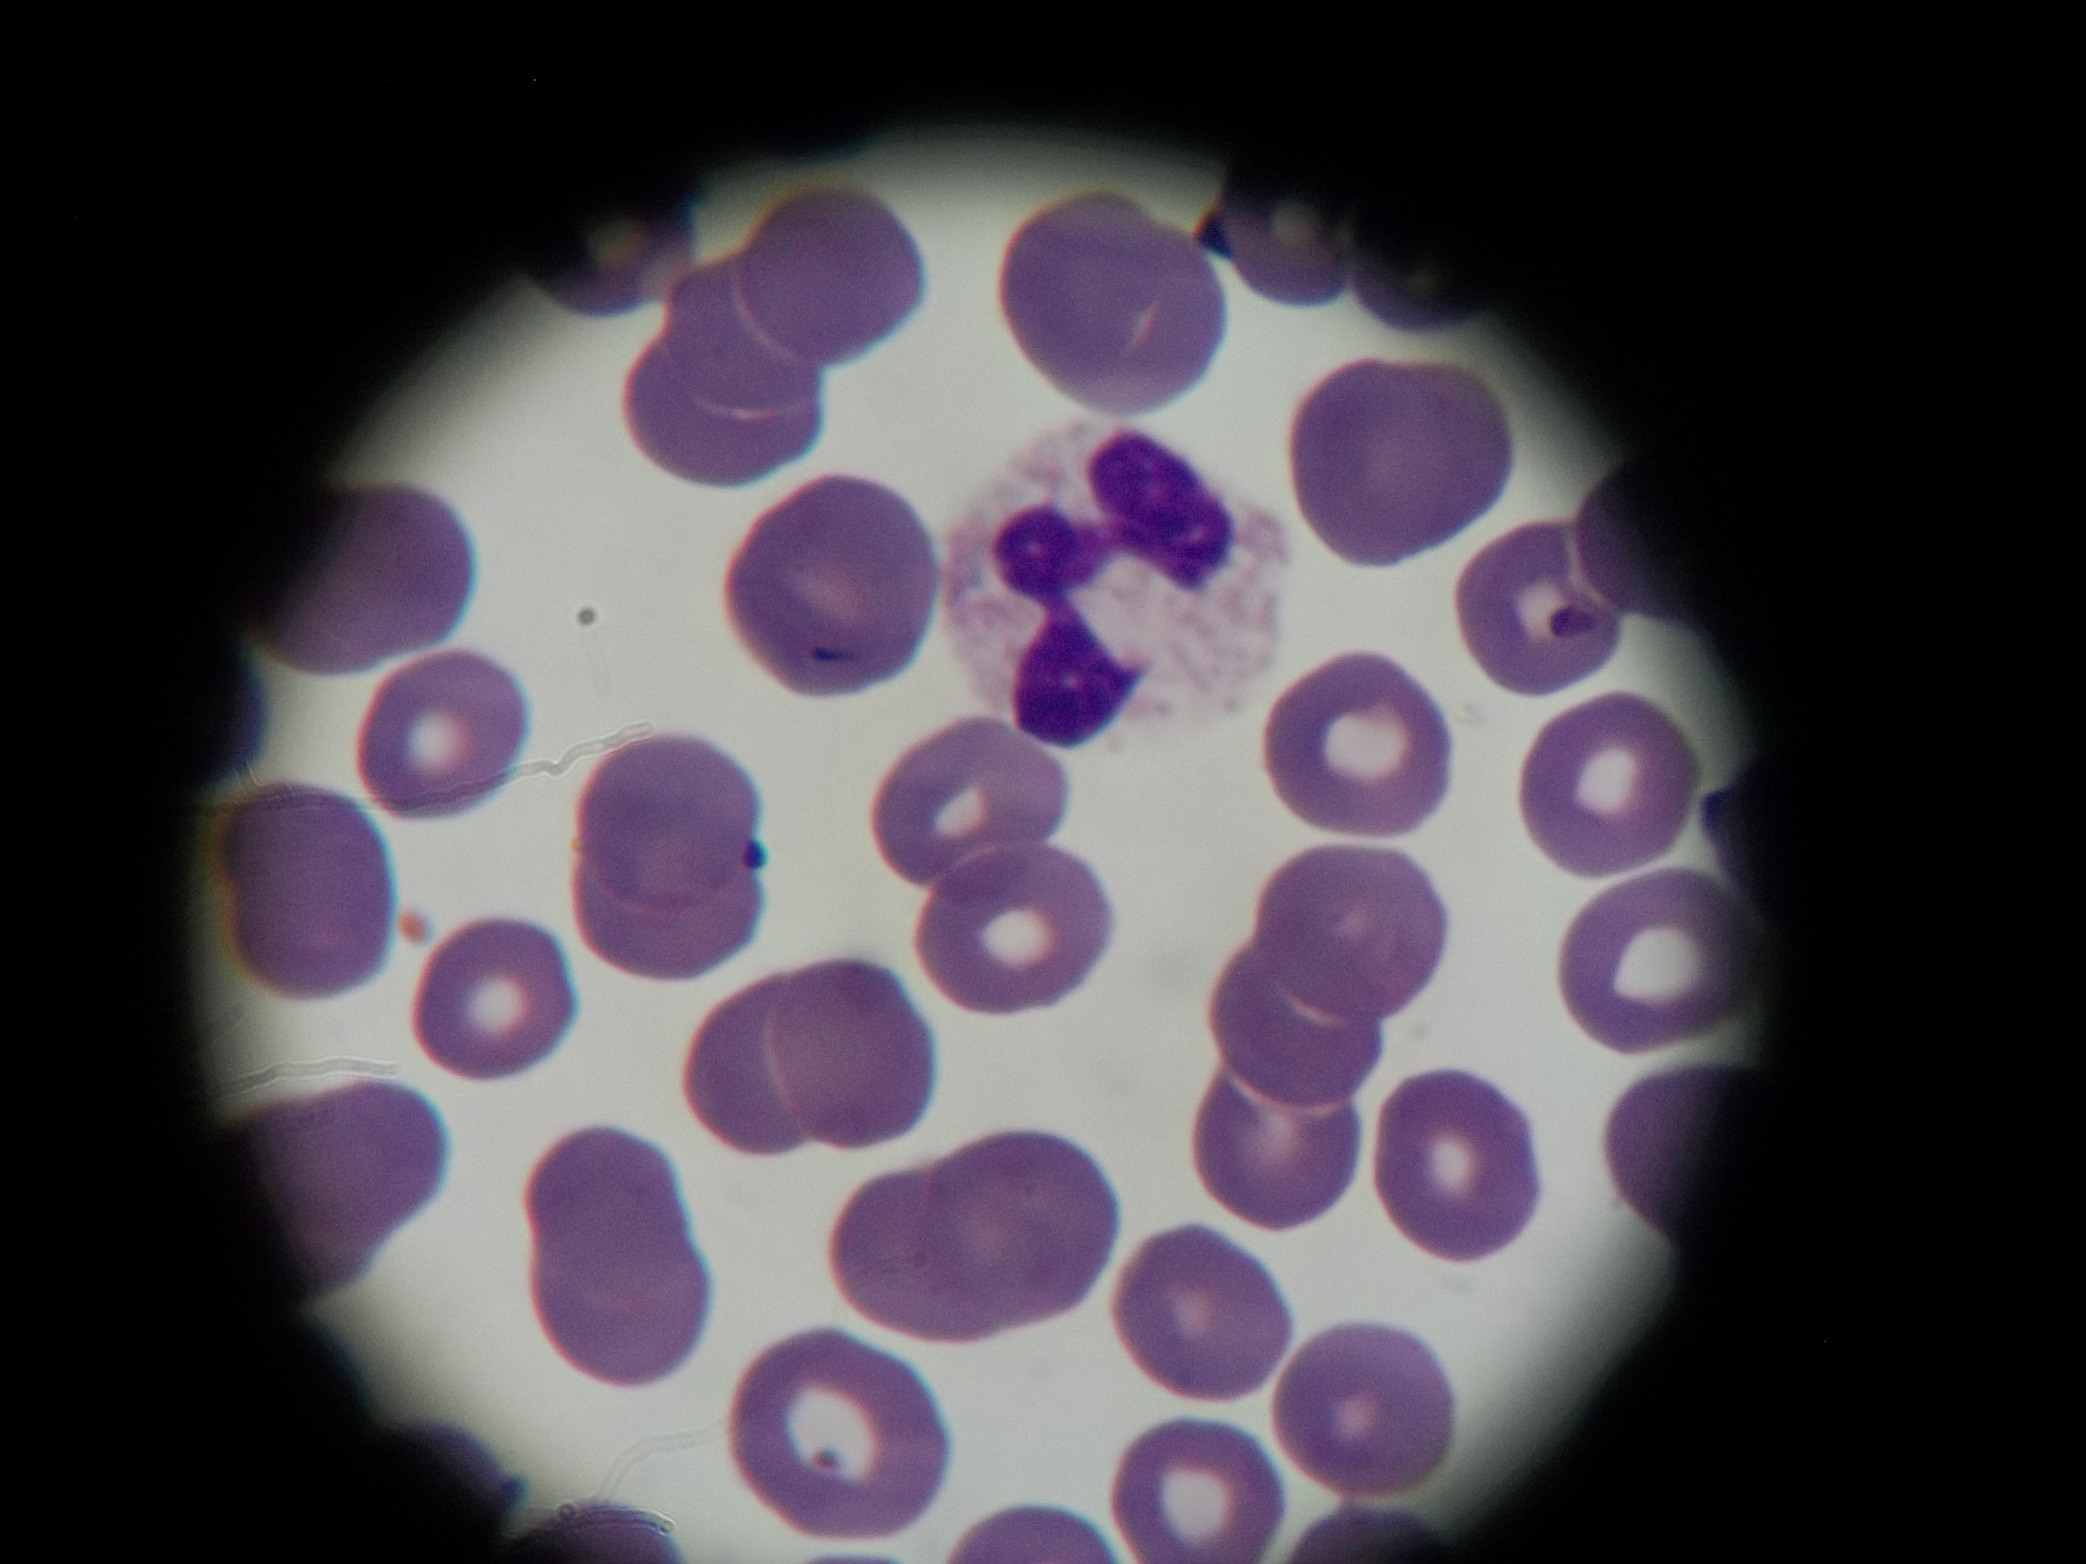
Neutrophils (Figure 1), also called polymorphonuclear leukocytes, are among the most numerous leukocyte cells present in the blood and play a fundamental role in immune and inflammatory responses in humans. At the beginning of an inflammatory process, such cells are the first elements to pass through the walls of blood vessels and reach the site of inflammation. They are morphologically distinguished by the multi-lobed nucleus and abundant granules present in the cytoplasm (ABBAS et al., 2008; GARCIA, 2010; GREER, 2009; TOLEDO, 2007).
Figure 1 – Neutrophils in the blood. Photographic documentation of the Laboratório de Métodos Epidemiológicos e Computacionais em Saúde (L-MECS), Universidade Federal de Viçosa.

Originated from pluripotent stem cells, neutrophils are produced in the bone marrow, in a process called hematopoiesis. Cells that belong to the group of myeloblasts give rise sequentially to promyelocytes, myelocytes, metamyelocytes, and rods. Then, the cells of the latter kind finally differentiate into neutrophils.
Mature neutrophils present many types of beads, among which four are well defined (GAUT et al., 2001; GARCIA, 2010):
a) the azurophil granules, also called primary, formed during the promyelocytic stage, are able to fuse with phagocytic vesicles. Components such as lysozyme – that degrade bacterial peptidoglycan – and myeloperoxidase – potent bactericidal oxidant, whose green color is characteristic of purulent exudate rich in neutrophils – are also present;
b) specific, or secondary, granules arise during development in the bone marrow and are intended for release to extracellular space. Their components have antibacterial action. Apolactoferrin, for instance, binds to iron and prevents bacteria to capture this element for growth;
c) the gelatinase, or tertiary, granules resemble specific granules. However, contain less amount of anti-microbial agents in their composition;
d) the secretory vesicles contain receptors of membranes that will be incorporated to the neutrophil surface.
The response of polymorphonuclear leukocytes to infection depends on an appropriate molecular signal. Bacteria present on their cell surface pathogen-associated molecular patterns – PAMPs – which are structures that can be lipopolysaccharide, lipoteichoic acid, peptidoglycan, and lipoproteins, among others (SIQUEIRA-BATISTA et al., 2011). PAMPs are identified by neutrophils (and also by macrophages and dendritic cells) through pattern recognition receptors (PRRs), notably the Toll-like receptors that are part of a large group of ten different receptors. This interaction initiates immune response, as the PAMPs-PRRs connections trigger molecular mechanisms leading to the production of inflammatory cytokines and adhesion molecules that promote the expansion of recruitment of neutrophils and macrophages to the site (FERRAZ et al., 2011). The migration of neutrophils is accomplished by selectins and integrins with activation and adhesion to endothelial cells that emit microscopically visible pseudopods which allow migration into the tissue (GREER, 2009; CRUVINEL, 2010).
Neutrophils are key participants in the innate immune response and they have an important role in the early stages of inflammatory reactions through their quick migration to sites of infection which is mediated by chemotactic cleavage products of complement fractions – C3a and C5a – releasing of tumor necrosis factor (TNF), interleukin 1 (IL-1), and chemokines. These are the main cytokines related to recruitment of these cells.
Polymorphonuclear leukocytes persist for a long period at the site of inflammation, acting also in the intake and degradation of components of the inflammatory process (ABBAS et al., 2008; GREER, 2009). Digestion of bacteria occurs with morphological change of these microorganisms – after phagocytosis – with subsequent release of bacterial fragments in the surrounding medium. The elimination of the organism depends on the generation of reactive oxygen metabolites and release of microbicidal substances (DE TOLEDO, 2007; ORDENFELT & TAPPER, 2011).
The oxidizing agents are considered central in the response mechanism that involves neutrophils. During a bacterial infection neutrophils activate their intracellular antimicrobial system in an environment in which various substances act on the pathogen by different pathways such as: (i) oxygen dependent – performed by the systems myeloperoxidase-independent, myeloperoxidase-mediated, hydrogen peroxide (H₂O₂), and superoxide – or (ii) oxygen independent – implemented by acids, lysozyme, lactoferrin and defensin (DE TOLEDO, 2007; GREER, 2009). Some of these constituents act in breach of the bacterial membrane – such as defensins and lysozyme – and others can interfere with iron-dependent metabolic pathways, such as lactoferrin. Recent studies have shown that polymorphonuclear leukocytes may also act in the formation of neutrophilic extracelular traps that are composed by nuclear components and granular substances capable of destroying extracellular bacteria and eliminating virulence factors (CRUVINEL, 2010).
The main mechanisms for removing tissue of neutrophilic cells recruited to areas of inflammation are apoptosis and phagocytosis by macrophages (BRATTON & HENSON, 2011). The apoptotic process is accompanied by morphological changes with particular attention to the formation of pyknotic nuclei. It is essential that neutrophils remain intact so to prevent the leakage of potentially toxic contents to the tissues before being phagocytosed by macrophages (CRUVINEL, 2010; DE TOLEDO, 2007; GREER, 2009). It has been recently described the mechanism of autophagy in neutrophils that may lead to apoptosis. The participation in the tissue clearance of these cells remains under investigation (VON GUNTEN & SIMON, 2007; HOTCHKISS et al., 2009; BRATTON & HENSON, 2011).
It is noteworthy that the number of neutrophils is notoriously increased in bacterial infectious processes – by augmented production and release by bone marrow – which constitute laboratory markers of the occurrence of such infections. It is fundamental to understand the neutrophils interactions with microorganisms – particularly bacteria – in order to unravel the complex mosaic of diseases caused by bacterial infections.

3 IMMUNE RESEARCH USING MULTIAGENT SYSTEMS
Multiagent Systems (MAS) have been used in computational methods for simulation and comprehension of complex systems, such as IS. In the MAS approach, only the basic entities that make up the system and their relations need to be modeled and implemented, on the assumption that the collective complex behavior will emerge from the interactions between the basic entities. Some MAS dedicated to the investigation of the IS have been proposed, including (i) BIS – The Basic Immune Simulator (FOLCIK et al., 2007) – developed to study the interactions between innate immunity cells and the adaptive immunity cells, and (ii) the AutoSimmune – designed by Possi and colleagues (POSSI 2012; SILVA et al., 2012), inspired by BIS – originally designed for researching autoimmune events. AutoSimmune was developed using the framework Repast Simphony – a free and open source system widely used in agent-based modeling (NORTH et al., 2005) – with the bottom-up approach that is a characteristic of reactive MAS. Notice that agents in this case are able to perceive the environment, to act on it, and to store states. Each agent represents an entity of the real system. Additionally, such agents may be heterogeneous, i.e., each one has its own states and rules, being able to interact with others.
In AutoSimmune time is discretized. The unit of time is called tick. For each tick, all events scheduled for that moment take place and have to be completed before the start of the next tick. As a result, the state of the environment evolves in a synchronized way.
The agents of AutoSimmune represent IS entities, such as cells (B lymphocytes, T lymphocytes, macrophages, mast cells, natural killer cells, and neutrophils), antibodies, antigens (bacteria and viruses), and cytokines: PK1 (representing stress factors released by tissues under injury caused by infection or immune response), MK1 (the set of pro-inflammatory substances in the innate immune response), MK2 (the set of anti-inflammatory substances in the innate immune response), CK1 (referring to the set of pro-inflammatory substances in adaptive immune responses), CK2 (referring to the set of anti-inflammatory substances in the adaptive immune response), NECROSIS (representing the cellular debris derived from necrotic process), and APOPTOSIS (which refers to the remains of cells undergoing apoptosis – i.e. programmed cell death). Tissue zones were also modeled: Upper airway (Figure 2), kidneys, lymph node, circulation, bone marrow, and thymus.

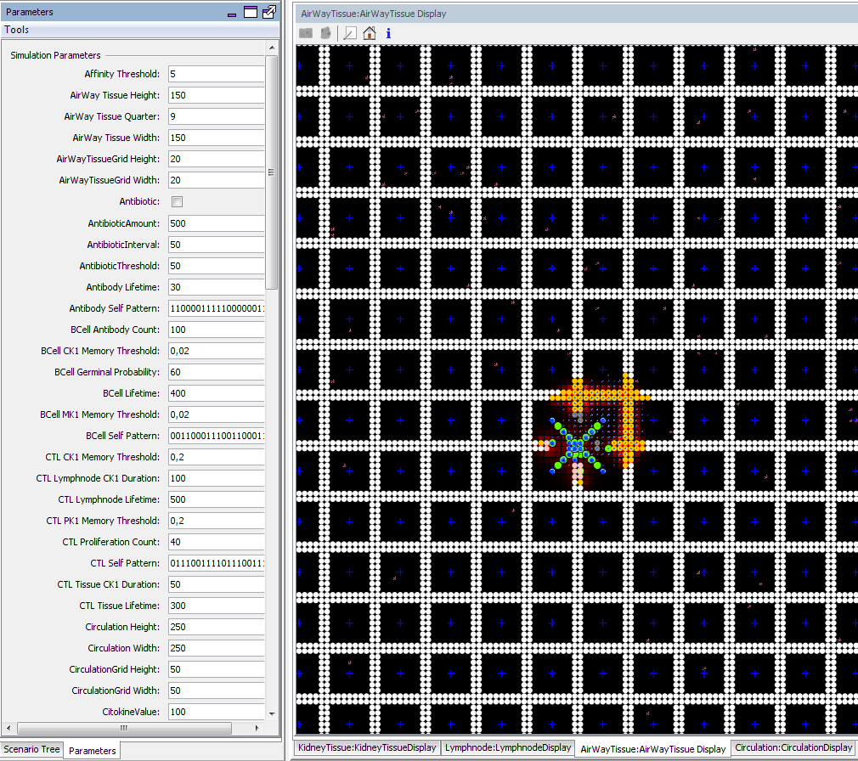
Figure 2 - Picture of AirWayTissue zone implemented in AutoSimmune. Taken from Bastos (2013).

AutoSimmune has been used to investigate the role of mast cells in controlling inflammation (SILVA et al., 2012), and to study the immune response in post-infectious glomerulonephritis by bacterium Streptococcus pyogenes (BASTOS, 2013). There are, additionally, important investigation propositions using AutoSimmune simulator to the study of Chagas' disease, falciparum malaria, and sepsis (SIQUEIRA-BATISTA et al., 2012b).

4 NEUTROPHIL COMPUTATIONAL MODEL
Neutrophils are represented in AutoSimmune by the agent Neutrophil (artificial neutrophils). It simulates what happens in vivo, i.e., microorganisms (bacteria) are lysed and phagocytosed by neutrophils. This process occurs in the human body by the joint action of oxygen free radicals generated by neutrophils and cytotoxic proteins from cytoplasmic granules (ABBAS et al., 2008).
In AutoSimmune, Neutrophil agents, implemented by the class Neutrophil, are inserted in the Bone Marrow zone, implemented by the class BoneMarrow. Notice that the concept of class here is that of Object Oriented Programming. A class, in this case, is a piece of code that defines entities (or objects) of a particular kind in the program. After being inserted in the Bone Marrow zone, Neutrophil agents (or objects) move through the Circulation zone until reaching the Tissue zone through the portals (classes: TissuePortal, CirculationPortal, and LymphnodePortal), which are responsible for making the connections between zones. The artificial neutrophils can reach different areas of the system – such as the AirWayTissue and KidneyTissue zones – when they perceive the presence of the pro-inflammatory cytokine MK1 (which has the role of attracting such agent) simulating the events chemotaxis and diapedesis. When entering a zone, the Neutrophil agent follows the cellular stress signaling substance (PK1), moving around until finding the site of infection. This agent looks for cells that are emitting PK1, and it is also able to identify microorganisms (bacteria), taking into account the molecular affinity (affinityThreshold parameter), represented in the system as a string of contiguous bits present in each agent (Figure 3).
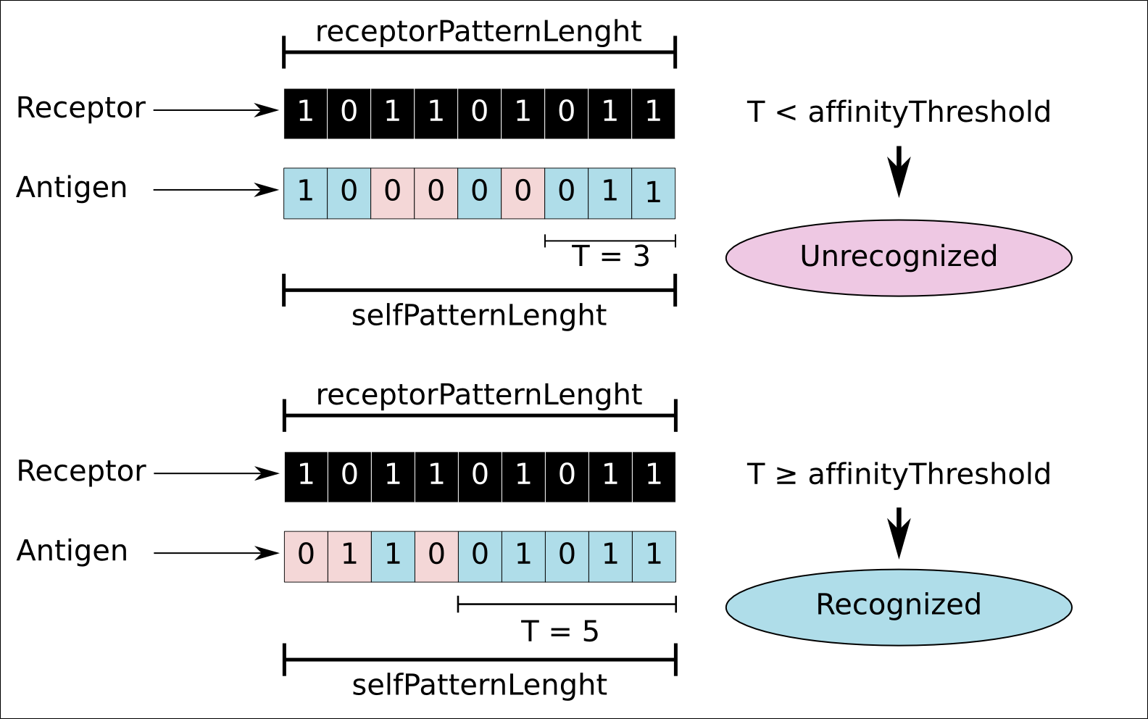
Another important event simulated in AutoSimmune is the inflammatory process as a result of phagocytosis of several entities, such as: Dead cells, pathogens presenting PAMPs, and antigen-antibody complexes, i.e., antibodies bound to any antigen. The artificial elements phagocytosed by neutrophils are destroyed in the simulator.
Figure 3 - Illustration of the degree of affinity calculation in AutoSimmune. In this case, the blue bits of the antigen indicate a match to the receptor bits in the same position. Pink indicates a mismatch for the given position. The largest common subsequence T of matching bits is marked as the largest contiguous sequence of blue bits. The sequences do not need to be necessarily aligned. In the example, it is assumed that the affinityThreshold parameter is equal to 4 (POSSI, 2012). Taken from POSSI (2012).

The rules of Neutrophil agent are illustrated in Figure 4 as a finite state machine.

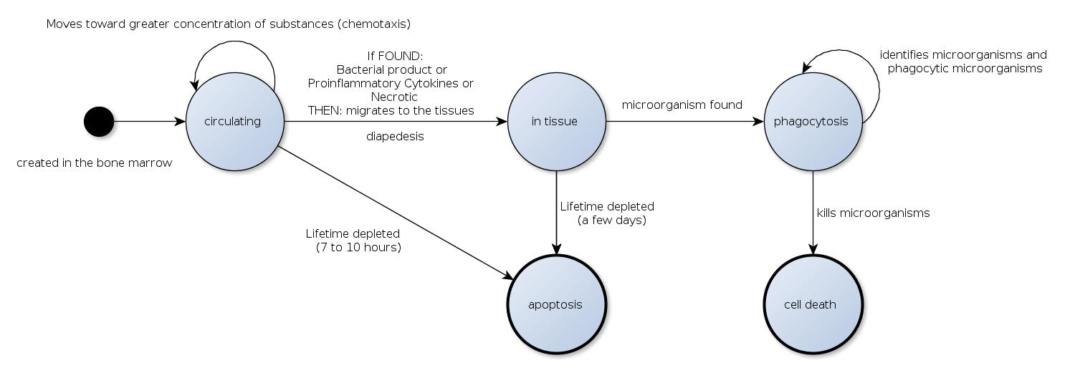
Figure 4 - Rules of the Neutrophil agent in AutoSimmune. The black circle means initial state, while a thicker circle line indicates final state. Taken from POSSI (2012).

Neutrophil agent changes its state – to cell death or apoptosis – when its lifetime ends, simulating what occurs in the human body (HENSON & BRATTON, 2011).
Preliminary experiments with the use of AutoSimmune have been described, specially regarding the role of artificial neutrophils. Bastos (2013) highlights the significant role of Neutrophil in the immunopathogenesis of post-streptococcal glomerulonephritis (PSGN), a human disease characterized by the presence of proliferative lesions in the renal glomeruli due to an infection in the upper airways or skin by the bacterium Streptococcus pyogenes. Simulation of PSGN was performed in AutoSimmune. After insertion of S. pyogenes in AirWayTissue zone, the innate immune system cells are immediately activated. Thus, natural phagocytes, including neutrophils, initiated phagocytosis of bacteria as well as necrotic cells, sending inflammatory signals to other agents. The adaptive immune response is then activated. Consequently, B cells start producing antibodies that are released into the bloodstream and, according to their specificity, bind to pathogenic bacteria to form immune complexes. These, in turn, when filtered by the kidney are trapped in the glomeruli that end up as targets for neutrophils and macrophages, starting the process of glomerular injury (TRABULSI & ALTERTHUM, 2008).
Neutrophils play an important role in the immunopathogenesis for acting in the lysis of bacteria (BASTOS et al., 2013a). According to Bastos and colleagues (2013b), in a demonstration of infection with bacterial activity including the presence of neutrophils (Figure 5), the immune response was faster when compared to the simulation of the same scenario without the presence of these cells (Figure 6).
Número de agentes | 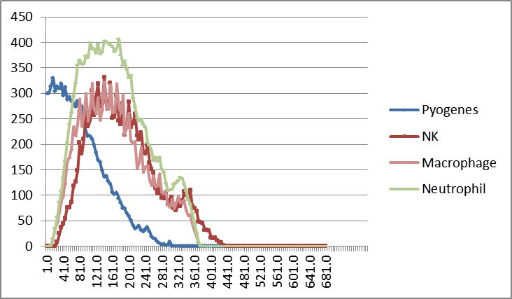
 | Ticks
Figure 5 - Bacterial infection of the upper airways (with neutrophils). Taken from Bastos (2013).

Número de agentes | 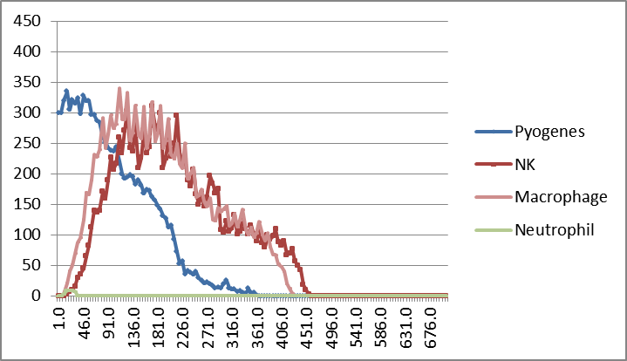
 | Número de ticks
Figure 6 - Bacterial infection of the upper airways (without neutrophils). Taken from Bastos (2013).

When analyzing Figure 5, one can realize the great performance of Neutrophils in the inflammatory process triggered by S. pyogenes (Agent Pyogenes), highlighting that the disappearance of bacteria occurs several ticks before when Neutrophils are present.

5 CONCLUSION
A computational investigation of the immune system might lead to new hypotheses, allowing the conduction of preliminary tests before the use of in vitro and in vivo experiments, additionally contributing to broaden the knowledge about pathophysiology of human diseases. In this context, in silico investigations of the role of neutrophils in bacterial diseases – whose early design was presented in this brief manuscript – could allow the preparation of more accurate and conclusive experiments and analyses, for what we point two key benefits: (i) The deepening of studies in immunology and (ii) the advance of bioinspired algorithms that have been the basis of several computational solutions for all sort of complex problems, including the field of public health.

ACKNOWLEDGMENT
We would like to thank the funding agencies FAPEMIG and CNPq for the financial support for this project.

REFERENCES
ABBAS, A. K.; LICHTMAN, A. H.; PILLAI, S. Imunologia Celular e Molecular. 3.ed. São Paulo: Elsevier, 2008.
BASTOS, C. A. Simulação computacional do SI através de sistemas multiagentes: um estudo da resposta imune e da terapêutica antimicrobiana na glomerulonefrite pós-infecciosa (GNPE) por Streptococcus pyogenes. 2013. 105 f. Dissertação (Mestrado). Departamento de Informática, Universidade Federal de Viçosa, Viçosa, MG.
BASTOS, C.A.; OLIVEIRA, A.P.; GOMES, A.P.; POSSI, M.A.; SANTANA, L.A.; CERQUEIRA, F.C.; SIQUEIRA-BATISTA, R. Simulação do sistema imunológico por meio de sistemas multiagentes: um estudo da resposta imune na glomerulonefrite pós-infecciosa (GnPE) por Streptococcus pyogenes. Disponível em: <http://www.lbd.dcc.ufmg.br/colecoes/wim/2013/002.pdf>. Acesso em: 14/12/2013. 2013a.
BASTOS, C. A.; OLIVEIRA, A. P.; GOMES, A. P.; POSSI, M.; SANTANA, L. A.; CERQUEIRA, F. R.; SIQUEIRA-BATISTA, R. Simulação do sistema imunológico por meio de sistemas multiagentes: um estudo da resposta imune na glomerulonefrite pós-infecciosa (GnPE) por Streptococcus pyogenes. Anais do XXXIII Congresso da Sociedade Brasileira de Computação. Maceió: Sociedade Brasileira de Computação, p. 1093-1102, 2013b.
BAXT LA, GARZA-MAYERS AC, GOLDBERG MB. Bacterial subversion of host innate immune pathways. Science, v. 340, n.6133, p.697-701, 10 mai. 2013.
BRATTON DL, HENSON PM. Neutrophil clearance: when the party is over, clean-up begins. Revista Trends in Immunology, v.32, n.8, p.350-357, ago. 2011.
BUCHALLA, C. M.; WALDMAN, E. A.; LAURENTI, R. A mortalidade por doenças infecciosas no início e no final do século XX no Município de São Paulo. Revista Brasileira de Epidemiologia, v.6, n.4, p.335-344, dez. 2003.
CRISS AK, SEIFERT HS. A bacterial siren song: intimate interactions between Neisseria and neutrophils. Revista Nature Reviews Microbiology, v.10, n.3, p.178-190, jan. 2012.
CRUVINEL, W.M.; MESQUITA-JÚNIOR, D.; ARAÚJO, J.A.P.; CATELAN, T.T.T.; de SOUZA, A.W.S.; da SILVA, N.P.; ANDRADE, L.E.C. Sistema imunitário parte I – Fundamentos da imunidade inata com ênfase nos mecanismos moleculares e celulares da resposta inflamatória. Revista Brasileira de Reumatologia, v.50, n.4, p.434-461. 2010.
DE TOLEDO, K.A. Da ativação de neutrófilos pela lectina MNCF decorrem transcrição gênica e secreção de mediadores sustentadas em ambiente anti-inflamatório. 2007. 111 f. Tese (Doutorado em Ciências) – Faculdade de Medicina de Ribeirão Preto, Ribeirão Preto, SP.
FERRAZ, E.G; SILVEIRA, BBB; SARMENTO, VA; SANTOS, JN. Receptores toll-like: ativação e regulação da resposta imune. Revista Gaúcha de Odontologia, v.59, n.3, p. 484-490. 2011.
FOLCIK, V.A.; AN, G.C.; OROSZ, C.G. The basic immune simulator: an agent-based model to study the interactions between innate and adaptive immunity. Revista Theoretical Biology and Medical Modelling, v. 4, p. 39, set. 2007.
GARCIA, V.S.G. Efeitos de flavonoides na captação de HOCI produzido por neutrófilos ativados e modulação do fator de transcrição NF-kB em células THP-1 – análise da relação estrutura-atividade. 2010. 214 f. Dissertação (Mestrado em Bioquímica) – Faculdade de Ciências, Universidade de Lisboa.
GAUT, J.P; YEH, G.C.; TRAN, H.D.; BYUN, J.; HENDERSON, J.P.; RICHTER, G.M.; BRENNAN, M.L.; LUSIS, A.J.; BELAAOUAJ, A.; HOTCHKISS, R.S.; HEINECKE, J.W. Neutrophils employ the myeloperoxidase system to generate antimicrobial brominating and chlorinating oxidants during sepsis. Proceedings of the National Academy of Sciences, v.98, n.21, p.11961-11966, oct. 2001.
GREER, J.P.; FOERSTER, J.; RODGERS, G.M.; PARASKEVAS, F.; GLADER, B.; ARBER, D.A.; MEANS-JUNIOR, R.T. Wintrobe’s clinical hematology. 12. ed. Philadelphia: Wolters Kluwer Health/Lippincott Williams & Wilkins, 2009.
HOTCHKISS, R. S., STRASSER A, MCDUNN JE, SWANSON PE. Cell death. New England Journal of Medicine, n.361, p. 1570-1583. 2009.
LUNA, E. J. A. A emergência das doenças emergentes e as doenças infecciosas emergentes e reemergentes no Brasil. Revista Brasileira de Epidemiologia, v.5, n.3, p.229-243, Dez. 2002.
NORDENFELT P, TAPPER H. Phagosome dynamics during phagocytosis by neutrophils. Journal of Leukocyte Biology, v.90, n.2, p.271-284, ago. 2011.
NORTH, M. J.; HOWE, T. R.; COLLIER, N. T.; VOS, J. R. The repast simphony development environment. In: Proceedings of the Agent 2005 Conference on Generative Social Processes, Models, and Mechanisms. [S.l.: s.n.] 2005.
POSSI, M. A. Uma ferramenta para simulação do SI através de sistemas multiagentes: um caso de estudo da autoimunidade. 2012. 106 f. Dissertação (Mestrado) - Departamento de Informática, Universidade Federal de Viçosa.
RIGBY KM, DELEO FR. Neutrophils in innate host defense against Staphylococcus aureus infections. Seminars of Immunopathology, v.34, n.2, p. 237-259, mar. 2012.
SILVA, C. C.; OLIVEIRA, A. P.; POSSI, M. A.; CERQUEIRA, F. R.; GOMES, A. P.; SIQUEIRA-BATISTA, R. Simulação in-silico do Sistema Imunológico: Modelando o comportamento do Mastócito. In: XII Workshop de Informática Médica (CSBC 2012 -WIM). 2012.
SIQUEIRA-BATISTA, R.; GOMES, A. P.; CALIXTO-LIMA, L.; VITORINO, R. R.; ALVAREZ-PEREZ, M. C.; MENDONÇA, E. G.; OLIVEIRA, M. G. A.; GELLER, M. Sepse: atualidades e perspectivas. Revista Brasileira de Terapia Intensiva, v. 23, n. 2, p. 207-216, 2011.
SIQUEIRA-BATISTA, R.; GOMES, A. P.; AZEVEDO, S. F. M.; VITORINO, R. R.; MENDONÇA, E. G.; SOUSA, F. O.; OLIVEIRA, A. P.; CERQUEIRA, F. R.; PAULA, S. O.; OLIVEIRA, M. G. A. Linfócitos T CD4+ CD25+ e a regulação do sistema imunológico: perspectivas para o entendimento fisiopatológico da sepse. Revista Brasileira de Terapia Intensiva, v.24, n.3, p. 294-301. 2012a.
SIQUEIRA-BATISTA, R.; GOMES, A. P.; POSSI, M.; OLIVEIRA, A. P.; SOUSA, F. O.; SILVA, C. C.; ROQUE-RINCO, U. G.; SANTANA, L. A.; CERQUEIRA, F. R.; FERREIRA, R. S.; MENDONÇA, E. G.; GELLER, M.; OLIVEIRA, M. G. A. Computational modeling of sepsis: perspectives for in silico investigation of antimicrobial therapy. In: ICAR 2012 - II International Conference on Antimicrobial Research, 2012, Lisbon. ICAR 2012 - Book of Abstracts, v. 1. p. 368-368. 2012b.
TRABULSI, L. R.; ALTERTHUM, F. Microbiologia. 5ª ed. São Paulo: Atheneu, 2008.
VON GUNTEN S, SIMON HU. Autophagic-like cell death in neutrophils induced by autoantibodies. Autophagy, n.3, p.67-68. 2007. [PubMed: 17102587] 25.

